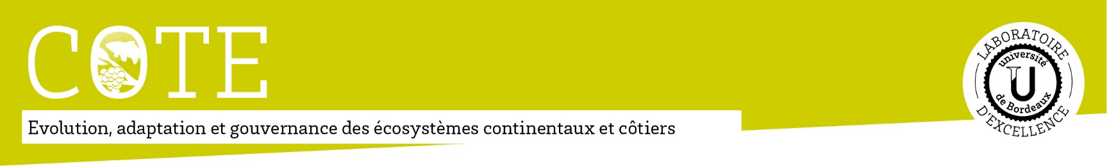
COTE Summer School
03-07 July 2017 – Bordeaux, France
“Weak signals and emerging issues in ecological transition”
The Summer School is part of the COTE Cluster of Excellence training programme and gathers PhD students in environmental sciences, each specialised in disciplines such as ecology, chemistry, biology or even sociology. Through talks, field trips and round tables with international experts on integrative ecology, the programme will provide a comprehensive and multidisciplinary approach on the definition, detection and role of weak signals and emerging issues in the ecological transition.
Theme & programme:
Climate-induced ecological changes as well as changes in consumption patterns have led to emerging issues. These often manifest before full development as weak signals, which can reveal important trends within ecosystems. However, it is often difficult to distinguish them statistically from ambient noise, or from random fluctuations of well-known signals. The COTE Summer School will show that scientists have more and more tools to monitor the planet. Its programme will cover several aspects of weak signals and emerging issues with presentations on new detectable substances in the environment, environmental reporting, ecological governance and political change for transition, weak signals and measurement techniques in marine, vineyard, forest and river ecosystems, and even on a paradigm shift related to the role of cloud microorganisms in atmospheric processes.
Conference speakers (non-exhaustive list):
Ivan Ascher, University of Wisconsin-Milwaukee, USA
Jelle Behagel, Wageningen University, the Netherlands
Gabrielle Bouleau, Irstea Bordeaux, France
Hélène Budzinski, CNRS Bordeaux, France
Laure Carassou, University of Bordeaux, France
Anne-Marie Delort, Institute of Chemistry of Clermont-Ferrand, France
Iñaki Garcia de Cortazar-Atauri INRA Avignon, France
Pieter Leroy, Radboud University Nijmegen, the Netherlands
Marcus Lindner , European Forest Institute, Finland
Participants, fees & how to apply:
The course is free of charge and includes accommodation and meals. Travel expenses must be covered by the participants. Mobility grants are available on demand (for details see application form). The course is in English and candidates must be PhD students.
To apply, please fill in the application form, upload a short CV, a cover letter and a letter of support from your supervisor in the online application form (http://cotesummerschool.u-bordeaux.fr/en/). If you also apply for a mobility grant, please add a letter justifying your request. All documents have to be merged into a single PDF file. Application deadline is 09 April 2017.
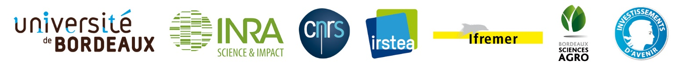
Contact:
For any questions, please contact the COTE managers at mission-labexcote@u-bordeaux.fr

